Afghani Chicken
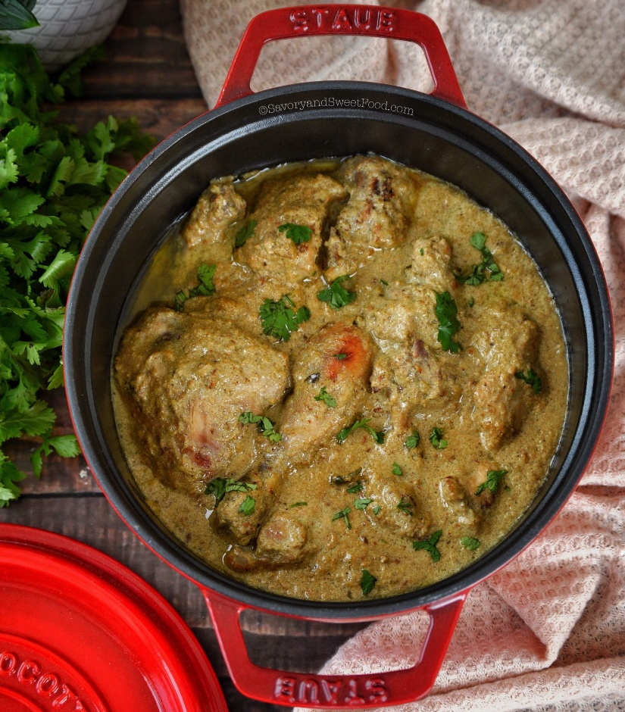

Ingredients:

- 1.5kg Chicken Breast
- 2 tbsp lemon juice
- 2 onions
- 3-4 green chilis
- 18-20 cloves garlic
- 4-inch piece ginger
- 2 handful coriander leaves
- 1 handful mint leaves
- 30 cashews
- 500g Greek yoghurt
- 500g cream (Schlagsahne)
- 2 tbsp kasuri methi
- 2 tsp black pepper
- 2 tsp garam masala powder
- 1 tsp cumin powder
- 2 tsp salt
- 6 pods cardamom
- 10 cloves
- Oil
- Butter
- Salt

Instructions:

- Take the chicken and cut into pieces.
- Take 2 onions and cut them into pieces. Put these onion slices in the mixer, add green chillies, garlic buds, ginger, cashews, coriander, mint leaves and the lemon juice. Grind it well. Green paste is ready.
- In another bowl, add the yoghurt and the cream. Then add the green paste, kasuri methi, black pepper, garam masala, cumin powder and the salt. Mix well.
- Add the chicken pieces to it and mix well so that the thick curd marinade coats the chicken well.
- Keep it aside for 15-20 minutes for marination.
- Heat 3 tbsp of oil in a flat bottom pan on medium heat. When the oil becomes hot enough, add chicken pieces one by one without the marinade.
- Fry them well from one side till golden brown and flip them one by one and fry from the other side as well.
- Take out the fried chicken in a plate.
- Add 2 tbsp of oil and 2 tbsp of butter in the same pan and heat on medium heat. Add green cardamom, cloves and cook for 1-2 mins.
- Add the marinade which wasn’t used to it and let it boil on medium heat. When it starts boiling, add the cooked chicken to it.
- Let the chicken cook in the gravy on medium heat for about 10 minutes while stirring occasionally.
- Delicious Chicken Afghani is ready to be served!

Video: https://www.youtube.com/watch?v=UL-lszdw3ww

